# **QUERY ANALYSER**

## **Objective**

Analyzing the long running queries in all aspects to identify pain points & scope for improving the query performance & runtime of the queries.

## **High Level Proposal**

1. Capture the required performance KPIs of long running queries from QUERY_HISTORY table
2. Get the Top 3 most time consuming steps from GET_QUERY_OPERATOR_STATS function
3. Apply different types of filters on each KPI as per the requirements in order to fetch the long running queries, below are the KPIs where we applied filters

i) TOTAL_ELAPSED_TIME

ii) QUERY_LOAD_PERCENT

iii) PARTITIONS_SCANNED

iv) BYTES_SPILLED_TO_REMOTE_STORAGE

v) TRANSACTION_BLOCKED_TIME

vi) QUEUED_OVERLOAD_TIME

vii) ERROR_MESSAGE

1. Based on each filter / condition, the recommendations will be given, by which the queries can be modified and improve the query load.

## **How to use / run the tool**

-> The code is written in the form of Stored Procedure using Python script, where we have used data frames in order to view the data and to apply filters.

## **Technical Implementation**

-> Compares the data and filter out the long running queries from the Query history table, and suggest some recommendations in order to improve the query load.

## **Prerequisites**

1. Fetching the required columns from QUERY_HISTORY table for one query id.
2. Capturing data(top running queries) from get_query_operator_stats.
3. Creating a temporary table and inserting the values for QUERY_ID, PARAMETERS, VALUE, RECOMMENDATION.
4. Applying filters on the below columns, to attain the certain results

i) TOTAL_ELAPSED_TIME

ii) QUERY_LOAD_PERCENT

iii) PARTITIONS_SCANNED

iv) BYTES_SPILLED_TO_REMOTE_STORAGE

v) TRANSACTION_BLOCKED_TIME

vi) QUEUED_OVERLOAD_TIME

vii) ERROR_MESSAGE

1. Creating an other procedure for QUERY_ANALYSER_REPORT on top of QUERY_ANALYZER procedure.
2. Initially Capturing the LAST_QUERY_START_TIME and INSERT_TIME into new table CONTROL_TABLE.
3. Fetching query_id and start_time which are older than 14 days from BAD_QUERY table of long running queries.
4. Calling QUERY_ANALYZER procedure for all the query ids and execution has to be happened continuously / loop (immediately right after the one statement).
5. Creating new table and capturing the values of QUERY_ID, PARAMETERS, VALUE, RECOMMENDATION values into QUERY_PERFORMANCE_KPI.
6. Updating LAST_TIMESTAMP as START_TIME which will be helpful in Step 6.

## **Source of data**

1. SNOWFLAKE.ACCOUNT_USAGE.QUERY_HISTORY
2. Get_query_operator_stats
3. WIMG_OBSERVABLITY.PERFORMANCE_MONITOR_SCHEMA.BAD_QUERY

## **Output Format & Details**

1. QUERY_ANALYZER Output : Basically it captured the below 14 keys

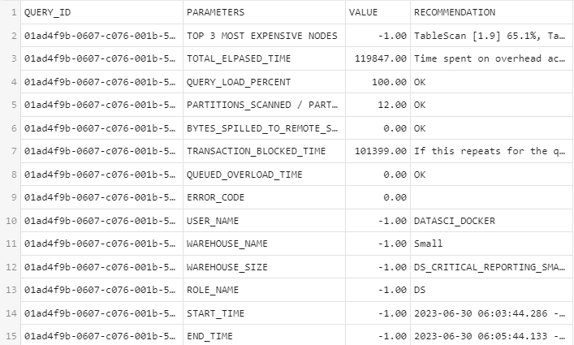

1. Control_Table Output :

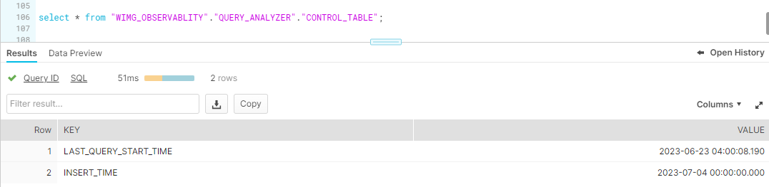

1. QUERY_PERFORMANCE_KPI Output :

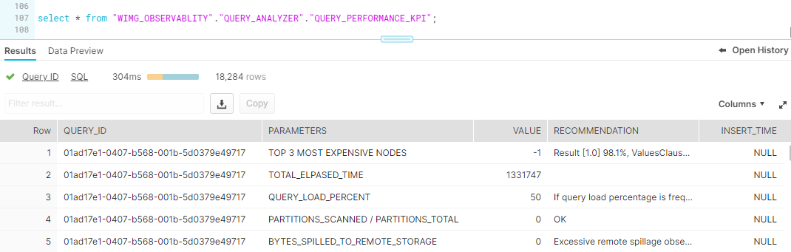

1. QUERY_ANALYSER_REPORT Output :

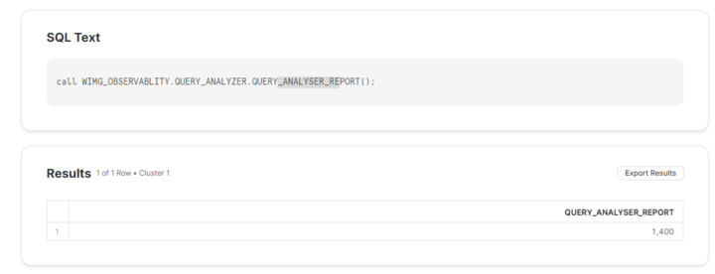

## Appendix

### Source Code